**Question:**

Implementing a program to find the quadratic roots of an expression given the coefficients of the expression.

import java.util.*;

import java.lang.Math;

class quadratic{

double a,b,c,d,r1,r2,choice;

quadratic(double w,double h,double l)

{

a=w;

b=h;

c=l;

}

void compute()

{

d=(b*b-4.0*a*c);

if(d>0.0)

{

r1=(-b+Math.sqrt(d))/2.0*a;

r2=(-b-Math.sqrt(d))/2.0*a;

choice=2.0;

}

else if(d==0.0)

{

r1=r2=(-b)/2.0*a;

choice=1.0;

}

else

{

r1=-b/2.0*a;

r2=(Math.sqrt(-d))/2.0*a;

choice=0.0;

}

}

void display()

{

compute();

if(choice==2.0)

{

System.out.println("Roots are real and disctinct\n"+"R1="+r1+"\nR2="+r2);

}

else if(choice==1.0)

{

System.out.println("Roots are real and equal\n"+"R1="+r1+"\nR2="+r2);

}

else if(choice==0.0)

{

System.out.println("Roots are imaginary\n"+"R1="+r1+"+i"+r2+"\nR2="+r1+"-i"+r2);

}

}

}

class Main{

public static void main(String args[])

{

double first,second,third;

Scanner sc=new Scanner(System.in);

System.out.println("Enter the coefficients of the quadratic expresion:");

double a=sc.nextDouble();

double b=sc.nextDouble();

double c=sc.nextDouble();

quadratic box1=new quadratic(a,b,c);

box1.display();

}

}

**Output:**

Real Roots:

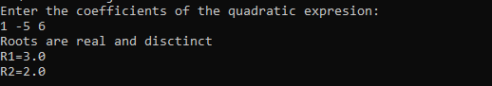

Equal Roots:

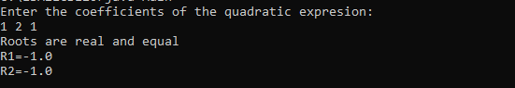

Imaginary Roots:

